Automotive Software Concepts: I.O.T Assignment

Car Indicator State Model.

Student Name: Conor Farrell;

Date of submission: 02/12/2016

About this project:

This circuit and it’s associated code aims to effectively model the operation of car indicators, including the hazards function. This is achieved with the use of the open-source Arduino hardware prototyping platform. The code and schematics contained within this document will therefore only work on an Arduino (or compatible system) in their present form.

The system has three inputs and three outputs.

The three inputs and a brief description of their functions:

* Left Button - Flashes the left indicator when held
* Right Button - Flashes the right indicator when held
* Hazard Switch - Flashes both indicators and the Hazard Light when

activated, regardless of the states of the other buttons

The three outputs are as follows:

* LEFT_IND - left indicator
* RIGHT_IND - right indicator
* HAZARD - hazard light

State Chart:

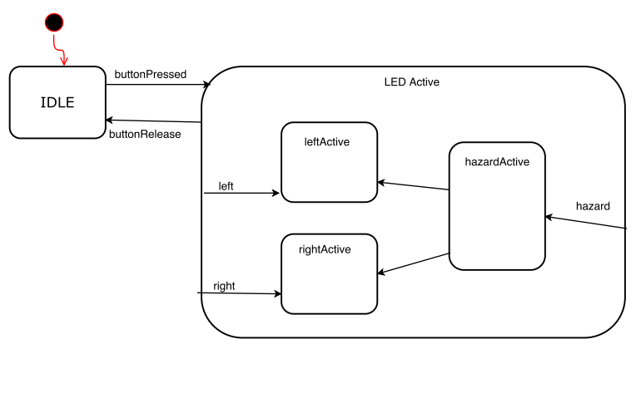

Drawn with: draw.io

Code:

The code is written in the Arduino IDE and is well documented. The full code for the board is below as shown in the GitHub repository. The code below is without comments, see the Arduino sketch for the commented version.



Schematic:

